1. Update Tagging (Diagram 4.1 Version 1.0 11/24/2015)

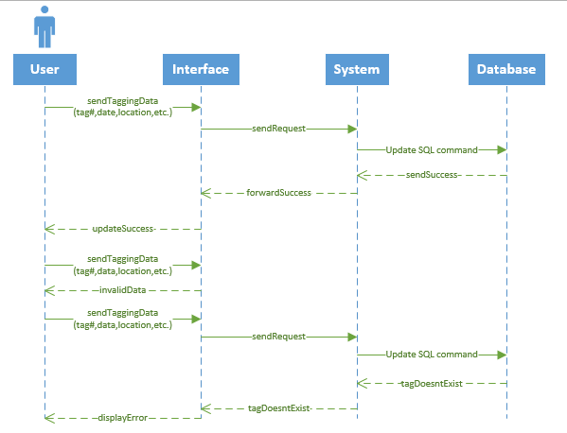

1. Update Sighting (Diagram 4.2 Version 1.0 11/24/2015)

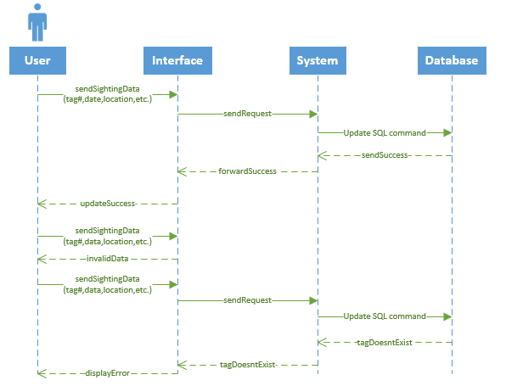

1. Update user`s own information (Diagram 4.3 Version 1.0 11/24/2015)

